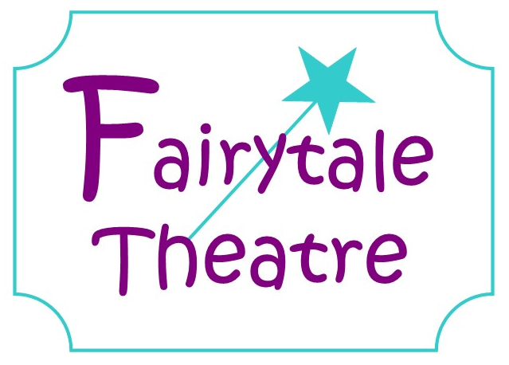

Accident/Incident Policy

All accidents/incidents to children and adults are recorded at Fairytale Theatre on the relevant Accident /Incident form as soon as possible, and are shown to the appropriate people and are discussed as necessary.

Accidents to Children
If a child has an accident whilst they are in our care. Staff must record:
- Location of Accident/Incident
- Name of child
- Date and time (this is particularly important in the case of head injuries)
- Nature and cause of accident
- Any visible signs of injury e.g. bruising. State where marks are located. A check should be made during the session in case bruising occurs later and the record added to.
- Treatment given
- How the child responded to the injury – e.g. upset, not concerned, etc
- Name of staff filling in the form
- In the case of head injuries the child should be monitored regularly throughout the session and behaviour noted.
- At the end of the session the record must be read and signed by the parent/carer
- In the case of an injury being caused by another child, that child’s name should not be included in the report but referred to as ‘another child’. An ‘Incident’ report can be made for the offending child, on paper form.

IN AN EMERGENCY:
When the accident/incident is more severe and life threatening:
- The child must not be taken to hospital by car
- If the child requires hospital admission an ambulance will be called – dial 999
- Parents must be notified immediately
- If parents are unavailable, notify emergency contact number from registration form.
- Ensure all medical records are taken to the hospital (consent form)
- Keep other children distracted and reassured
- If an ambulance is ready to transport and a parent is not present a member of staff will accompany.

Accidents to Adults
When an adult whether it be a member of staff, visitor or parent has an accident, a record must be kept detailing the...
- Location of Accident
- Name of injured person
- Date and time of accident
- Particulars of injury/accident
- Activity at time of injury/accident
- Place of injury/accident
- Details of injury/accident
- First aid treatment given (if any) including if injured person taken to hospital. If so which hospital?
- Names of person(s) witnessing the injury/accident and signature(s)
- Name of person dealing with the injury/accident and signature(s)

If a member of staff has to be taken to hospital due attention must be given to ratios and another member of staff called in if necessary. The next of kin of the staff member should be notified.

