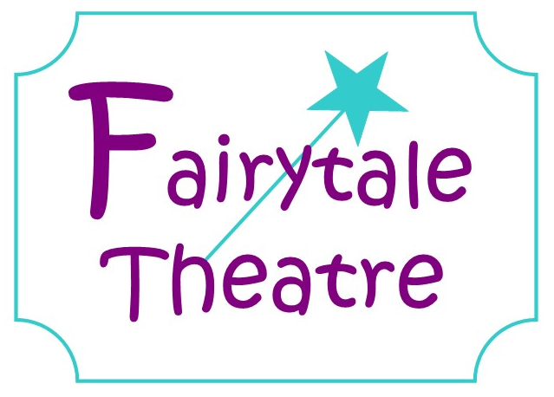

Terms and Conditions of Membership

Fees
- Fees will be paid before the start of every half term as outlined on the invoices sent out
- Fees can be paid via direct debit (details are outlined on invoice) or by cash. Cheques are accepted at the discretion of Fairytale Theatre staff
- Any bank charges incurred by Fairytale Theatre, that is not honoured, will be passed back to the individual
- All sessions must be paid for whether your child attends or not – you will not receive a refund for sessions you are unable to attend.
- All fees are charged half termly in advance and will sent out to you via email unless a paper copy is requested
- Siblings will now only receive one invoice, rather than individual invoices. These will still show the breakdown of each sibling.
- Late payment fees may be applied to accounts that get into arrears. Fairytale Theatre reserve the right to remove membership if fees aren’t paid or appropriate measures aren’t made to clear the debt.

Recommend a Friend Scheme
- You will receive a free session for every child you recommend who signs up to join Fairytale Theatre, you won’t receive a reward if they only attend a free taster session.
- You will receive your free session the next half term which will be shown on your invoice
- They must quote your child’s name when signing up.
- There is no limit on how many recommendations and free sessions you can receive.

Loyalty Scheme

- We are introducing a Sibling Loyalty scheme and offering a 10% discount for any Siblings who have attended Fairytale Theatre for a year on all their invoices.
- This will only be available for Siblings who have attended for a year or more and will be automatically added to your invoice
Session Cancellations
- If a session is cancelled by Fairytale Theatre due to staff illness or unforeseen circumstances then you will be refunded.
- The refund for cancelled sessions will be added to the invoice for the following half term, taking off a week for the cancelled session – we will not offer cash/bank transfer refunds. You will instead receive a free session next half term

Clothing
- Appropriate clothing must be worn at all sessions
- There is no uniform at Fairytale Theatre however we do have optional T-shirts available to purchase
- Closed toed sensible shoes (trainers are best) must be worn – no flip flops, sandals, wheelies or high heels
- Shoes must be worn at all times; no-one is to run around barefoot or in socks for health and safety reasons

Classes and Performances

- Students participate at their own risk and are obligated to inform Fairytale Theatre of any injuries or medical conditions (to be outlined on the registration form)
- Fairytale Theatre will take photographs and video footage during sessions, rehearsals and performances for use in our marketing and publicity material – by signing the consent form parents give their permission for these to be used. Children’s names will be not be published alongside the photographs
- Once dates for performances are announced – parents must ensure their child can attend all performances and inform Fairytale Theatre.
- We ask that when rehearsing for a performance parents support their children in line learning, practising songs and dance routines. It is their responsibility to work on this is their own time in order to prepare fully for the performance.
- At the beginning of rehearsals, students will be given; scripts, CD’s and lyric sheets which they are responsible for looking after. Any lost items can be replaced for a small fee which will be charged to you.

Leaving Fairytale Theatre

- Once your child has registered and joined Fairytale Theatre, there is no need to register every half term
- A minimum of 4 weeks’ notice in writing must be given to Fairytale Theatre if your child no longer wishes to attend sessions.
- If your child decides to leave part way through a half term and there is more than 4 weeks left of the term, you will not receive a refund for the remaining half term.
- If your child chooses to leave at the end of a half term will be invoiced an amount for the 4 weeks after the date your notice is given.
- Once Fairytale Theatre announces a performance date, any student who leaves during the rehearsals for the show will be required to cover all costs incurred by Fairytale Theatre including; costumes, props, CDs, scripts and lyric sheets, as well as the standard half termly costs up to the date of the performance IN ADDITION to the 4 weeks’ notice period.
- It is your responsibility to cancel any standing orders you have set up. We are under no obligation to refund payments made in error.

